Project Documentation: Employee Management System
Course: Java Fundamentals - Week 4 (Collections & File Handling)
1. Executive Project Overview
The Employee Management System is a console-based Java application designed to demonstrate the Java Collections Framework and Data Persistence. The primary objective of this project is to implement a robust data pipeline utilizing ArrayList and HashMap collections, while applying advanced Exception Handling protocols to ensure systemic stability during File I/O operations.
Key Objectives Met:
- Implementation of a Dual-Collection architecture for optimized sorting and O(1) quick lookups.
- Data persistence using Java Object Serialization to read/write state to local files.
- Strict exception handling to prevent application crashes from invalid user input (e.g., NumberFormatException).
- State synchronization across multiple data structures and external .dat files.
2. System Architecture & UML Design
The system relies on a modular architecture to separate data models from file handling utilities and business logic.
UML Class Diagram Definitions
Class: Employee
Description: Represents a serializable employee record.
Private Fields
- id: String
- name: String
- department: String
- position: String
- salary: double
- joinDate: Date
Constructor
- Employee(id, name, department, position, salary) (Note: joinDate is auto-generated)
Public Methods
- getId(), getName(), getDepartment(), getPosition(), getSalary(), getJoinDate()
- setName(), setDepartment(), setPosition(), setSalary()
- toString(): String
Class: EmployeeFileHandler
Description: Utility class strictly for persistent data storage operations.
Private Fields
- FILE_NAME: String (static final)
Public Methods
- saveToFile(ArrayList employees): void (static)
- loadFromFile(): ArrayList (static)
Class: EmployeeManagementSystem
Description: Central database controller and User Interface.
Private Fields
- employees: ArrayList (static)
- employeeMap: HashMap<String, Employee> (static)
- scanner: Scanner (static)
Public Methods
- main(String[] args): void (static)
- addEmployee(), viewAllEmployees(), searchEmployee(): void (static)
- updateEmployee(), deleteEmployee(), generateReports(): void (static)
3. Technical Implementation of Core Concepts
To ensure high code quality, specific Week 4 concepts were enforced:
Dual-Collection Architecture (Optimization):
The system utilizes an ArrayList<Employee> to maintain insertion order and facilitate linear iterations for generating statistical reports. Simultaneously, it uses a HashMap<String, Employee> mapped by Employee ID to achieve O(1) constant-time lookups for instantaneous searches, updates, and duplicate ID validations.
Exception Handling & Try-With-Resources:
File operations are wrapped in try-with-resources blocks (ObjectOutputStream and FileOutputStream). This guarantees that I/O streams are securely closed automatically, preventing memory leaks and file corruption even if an exception is thrown. User inputs are wrapped in while(true) loops with try-catch blocks to gracefully handle NumberFormatExceptions.
Data Serialization:
The Employee class implements the java.io.Serializable interface. This allows the system to convert the object graphs directly into byte streams, saving them to data/employees.dat without requiring complex manual string/CSV parsing logic.

4. Setup, Installation & Execution
Prerequisites:
- Java Development Kit (JDK) 11 or higher.
- Command-line interface / Terminal.
Steps to Run:
- Extract the project folder and navigate to the src/ directory.
- Compile the classes by executing: javac *.java
- Launch the application by executing: java EmployeeManagementSystem
- Use the numeric keypad to navigate the interactive menu. The system will automatically generate the file structure if it does not exist.
5. Comprehensive Testing Plan & Evidence
The system was subjected to rigorous testing to ensure edge cases and I/O streams were handled gracefully.
Test ID | Action Performed | Expected Result | Actual System Output | Status
TC-01 | Input alphabetic characters for Salary | Caught by NumberFormatException in try-catch | "Invalid input. Please enter a numerical value." | PASS
TC-02 | Attempt to add a duplicate Employee ID | Checked against HashMap.containsKey() | "Error: Employee with ID [X] already exists!" | PASS
TC-03 | Delete an employee and run a report | Reference removed from BOTH Collections; stats update accurately | "Employee [X] has been deleted." | PASS
TC-04 | Force exit application and reboot | ObjectInputStream accurately deserializes the binary file | Menu successfully reloads previous data | PASS
TC-05 | Search using O(1) ID lookup | Instantly returns the exact Employee object via HashMap | "Match Found: [Employee Details]" | PASS

6. Visual Documentation (Screenshots)
- Screenshot 1:
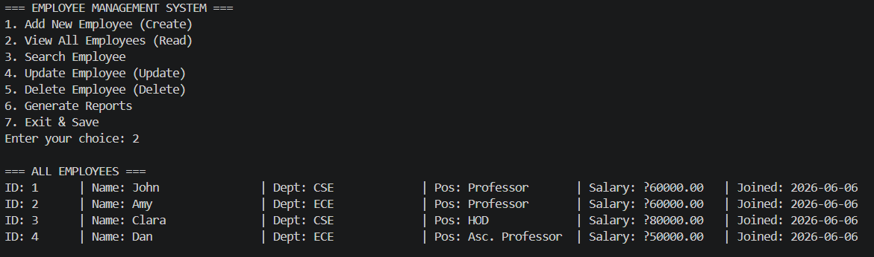

- Screenshot 2:
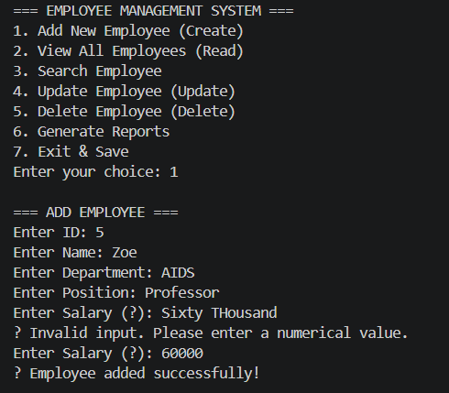
- Screenshot 3:
